Article
Evaluating Neus-Facto Lesion Surface-Area Measurement Using a 3D-Printed Anatomical Phantom
Roman Burkovskyi ¹, Mykhaylo Melnyk ¹ and Wojciech Zabierowski ^{2,}*
Academic Editor: Firstname Lastname
Received: date
Revised: date
Accepted: date
Published: date
Citation: To be added by editorial staff during production.
Copyright: © 2025 by the authors. Submitted for possible open access publication under the terms and conditions of the Creative Commons Attribution (CC BY) license (https://creativecommons.org/licenses/by/4.0/).
¹ Department of Computer Design Systems, Lviv Polytechnic National University, 3 Mytropolyta Andreya St., 79013 Lviv, Ukraine; rburkovskyi@gmail.com (R.B.); mykhaylo.r.melnyk@lpnu.ua (M.M.)
² Department of Microelectronics and Computer Science, Lodz University of Technology, 221 Wólczańska St., 93-005 Lodz, Poland; wojciech.zabierowski@p.lodz.pl (W.Z.)
* Correspondence: wojciech.zabierowski@p.lodz.pl
Abstract
Accurate measurement of the surface area of skin lesions and chronic wounds is a key element of monitoring their dynamics — both healing and progression — yet traditional manual methods are invasive, slow, and highly operator-dependent, while two-dimensional digital approaches based on smartphone imaging distort area geometry on curved anatomical surfaces. Three-dimensional surface reconstruction removes these limitations, and among current methods the family of neural implicit surfaces — in particular Neus-Facto — demonstrates the highest geometric accuracy in a recent empirical benchmark study. However, existing evaluations use a structured-light 3D scanner as the reference, whose own measurement error is confounded with the error of the method under test; the test phantoms are isolated from the anatomical context of the body, and repeatability is assessed on frame subsets of a single video. In this work we propose an alternative path for evaluating Neus-Facto: the reference geometry is defined not by measurement but by design — a digital CAD model realized as a 3D-printed anatomical foot phantom with an embedded lesion region. Capture is performed with a consumer-grade smartphone following a documented protocol; repeatability is assessed on genuinely separate physical sessions at different times, with variation in camera distance and viewpoint. This setup separates the error of the method from the error of the measurement reference and more closely reflects real clinical conditions.
Keywords: keyword 1; keyword 2; keyword 3 (List three to ten pertinent keywords specific to the article yet reasonably common within the subject discipline.)

1. Introduction
Skin lesions and chronic wounds impose a substantial clinical and economic burden on healthcare systems worldwide. Accurate and reproducible measurement of lesion area is a key element of monitoring healing dynamics, assessing treatment efficacy, and clinical documentation. In everyday practice such measurements are still predominantly performed manually — by planimetry on transparent film or with an ordinary ruler — which is invasive for the patient, slow, imprecise, and highly dependent on operator skill.
Digital two-dimensional approaches based on smartphone imaging partially solve the standardization problem, yet leave fundamental methodological limitations in place. The area computed as the number of pixels within a segmented region depends on the camera viewpoint and its distance to the object, and is in effect a projection of a three-dimensional surface onto the sensor plane. For lesions on curved anatomical surfaces — the foot, the shin, the heel — the area computed this way differs from the true one and varies for the very same lesion from one photograph to another [1–3]. Neither wound depth nor the perimeter on the three-dimensional surface can be reliably obtained this way.
Despite these limitations, smartphone imaging remains the most readily deployable input-acquisition modality: a modern smartphone is a tool already present in most healthcare facilities, including those operating under constrained equipment budgets. Dedicated 3D scanners, stereo rigs, and structured-light systems, while more accurate, require a dedicated budget, staff training, and physical integration into the clinician’s workflow.
Moving to three-dimensional reconstruction of the lesion geometry removes these limitations directly: given a digital surface model, the area can be computed viewpoint-invariantly as the sum of the areas of the triangles of a polygonal mesh (see Equation 2). The literature offers several competing directions — classical photogrammetry, neural implicit surface reconstruction, Gaussian Splatting [4], and single-image approaches with depth estimation by foundation models — reviewed in detail below. The quality of the resulting reconstruction depends both on the chosen method and, in a way that is often underestimated, on the quality of the input images: focus, exposure, lighting, and completeness of angular coverage.
Among neural approaches, the family of signed distance function (SDF) methods — NeuS [5], Neuralangelo [6], and especially the fast variant Neus-Facto from the SDFStudio framework [7] — demonstrates the highest geometric accuracy and repeatability in the recent empirical comparison SALVE [1]. However, the evaluation in SALVE was conducted on TraumaSIM silicone phantoms isolated from the anatomical context of the body: they are not constrained by the geometry of the body region where a real lesion would typically be located — and in clinical conditions that geometry substantially restricts the available capture viewpoints and, accordingly, has a critical impact on 3D reconstruction quality. Moreover, the phantoms themselves are large, saturated in color, and have exaggerated relief, which eases the feature-matching task for SfM/MVS algorithms and does not reproduce realistic conditions of clinical capture. The reference is a structured-light scanner — itself an empirical instrument with its own measurement error, which makes the behavior of the reconstruction method hard to separate from the error of the reference itself.

2. Related Work
The literature relevant to our topic can be roughly divided into two types of work: those proposing benchmark studies of 3D reconstruction methods, and those describing end-to-end pipelines for measuring and analyzing skin lesions. Direct medical works evaluating Neus-Facto specifically on a physical anatomical object are almost absent from the literature: besides SALVE [1], the closest is Syn3DWound [8], but that dataset is entirely synthetic.

2.1 Benchmark studies of 3D reconstruction methods
Benchmark studies focus on the empirical comparison of reconstruction methods by metrics of geometric accuracy, repeatability, and photometric rendering quality. In the medical context the key such work is SALVE [1], which compares nine methods (from COLMAP and Meshroom to SuGaR [9], 2DGS [10], Neuralangelo, Neus-Facto, and others) on three TraumaSIM silicone phantoms (types PIS3, PIS4, SD), captured with an iPhone 14 Pro Max and a Logitech 4K Webcam, with reference geometry from a Revopoint POP 2 structured-light scanner. According to SALVE’s results, Neuralangelo, Neus-Facto, and Meshroom consistently lead in accuracy, with Neus-Facto additionally demonstrating the best robustness to a change of capture device. In the authors’ words, the SDF formulation allows such methods to regularize noise in the input data, yielding accurate, repeatable, and smooth reconstructions [1]. This is what makes SALVE the most important direct reference point for our work and motivates the choice of Neus-Facto as the subject of a narrowly focused evaluation.
At the same time, SALVE leaves a number of methodological questions open: the error of the reference scanner itself is of the same order as the reported accuracy of the best methods — so interpreting the millimeter-scale results requires caution; “repeatability” is measured on frame subsamples of a single video rather than separate physical capture sessions; the wound region is delineated with a manual polygon, which substitutes for segmentation and introduces subjectivity; the dimensions of the phantoms are not stated in the paper.
Separately, the same group of authors released Syn3DWound [8] — a dataset of fully synthetic 3D wounds created in computer graphics. Syn3DWound is useful for testing segmentation models, but for evaluating 3D reconstruction methods on real medical objects it is unsuitable by construction: all input images are renders, which sidesteps precisely the problem these algorithms are deployed for in the clinic — reconstructing real surfaces from smartphone capture with all its inherent noise, distortions, and viewpoint constraints.
Among non-medical benchmark works featuring Neus-Facto, worth mentioning are NeRFBK [11] — a dataset by the Fondazione Bruno Kessler group comparing NeRF methods (including Neus-Facto and Nerfacto) on indoor and outdoor scenes with laser-scanning reference — and MuSHRoom [12], oriented toward joint reconstruction and novel-view synthesis in rooms captured with smartphones and a Kinect, with reference from a Faro scanner. DN-Splatter [13], although positioned as a new method (depth-and-normal priors for Gaussian Splatting), compares against SDFStudio methods in its experimental section; tellingly, the authors used default settings for Neus-Facto, which in practice rarely yield an optimal mesh without manual per-scene hyperparameter tuning. None of these non-medical benchmarks answers the question of how suitable Neus-Facto is for skin lesions in an anatomical context, so the methodological gap remains open.

2.2 End-to-end skin-lesion measurement pipelines
Another class of works proposes a complete pipeline for skin-lesion assessment — from capture to clinically interpretable metrics. Wound3DAssist [14] (the same group as SALVE) integrates Meshroom photogrammetry, SegFormer segmentation, ArUco-based scaling, and a periwound-tissue analysis module into a single framework for smartphone video. Testing on digital models, silicone phantoms, and real patients shows an error of about 1 mm per pixel, but the authors themselves acknowledge that a more precise assessment would require higher-resolution reference scans and controlled capture conditions [14].
The same group, in WoundNeRF [15], replaces classical 2D segmentation with 3D segmentation via a NeRF/SDF field with a semantic decoder. This substantially improves the multi-view consistency of segmentation masks, yet the evaluation itself is limited to manual comparison against clinician annotations, without an independent metric reference. Wang et al. [2] combine deep neural segmentation (M-CSAFN) with classical COLMAP photogrammetry for the analysis of facial port-wine stains; this work does not employ neural 3D reconstruction, and the measured mean relative error of 4.59% against a structured-light scanner is relatively high for clinical applications.
A common limitation of the pipeline works is that they evaluate the final product — the combination of reconstruction, segmentation, and scaling — as a single black box, which makes it hard to separate the contributions of each stage to the total error. Our work deliberately narrows the focus to evaluating one narrow component — 3D reconstruction with Neus-Facto — with a controlled input signal (a CAD reference defined by design rather than by measurement) and a documented smartphone capture protocol. This makes it possible to measure the contribution of the reconstruction algorithm itself, without conflating it with the errors of the reference or of other pipeline stages.

3. Aim and Contributions
This work focuses on evaluating the accuracy of 3D reconstruction of a skin lesion with Neus-Facto — a representative of the SDF family of neural implicit surface reconstruction methods, which in existing empirical comparisons [1] has proven to be among the most geometrically accurate and the most consistent in repeatability. The aim is to evaluate this method under conditions as close as possible to real clinical capture, yet with a reference strict enough to measure the contribution of the reconstruction algorithm itself rather than the accumulated error of the entire measurement pipeline.
The proposed experimental setup is deliberately chosen as an alternative to three evaluation models common in the literature:
- Instead of fully synthetic datasets (where all input images are computer renders of modeled lesions), we use real smartphone capture of a physical object, with all the noise, distortions, and viewpoint constraints inherent in real capture.
- Instead of isolated laboratory phantoms such as TraumaSIM (enlarged, saturated in color, with exaggerated relief of their own), we use a purpose-designed 3D-printed anatomical phantom in which the lesion region follows the real geometry of the body around it, rather than being a conveniently isolated surface.
- Instead of testing on real patients, where a reliable reference is practically impossible to establish without expensive specialized equipment, and repeated evaluation under identical conditions is complicated by changes in the lesion itself, skin stretching, positional variation, and other capture factors, the phantom’s CAD model is a deterministic and reproducible reference that allows the experiment to be repeated under controlled conditions.
The main contributions of this work are:
- A methodology for evaluating the accuracy of 3D reconstruction of skin lesions with reference geometry in the form of a digital CAD model, realized as a 3D-printed anatomical phantom.
- A documented consumer-grade smartphone capture protocol suitable for neural 3D reconstruction.
- An empirical assessment of the accuracy, repeatability, and sensitivity of Neus-Facto to capture conditions in a regime close to real clinical capture.
- An analysis of the influence of capture quality and reconstruction parameters on the final area-measurement error.

4. Theoretical Background

4.1 Why three-dimensional surface area is more accurate than a two-dimensional projection
Any image acquired by a single sensor is a two-dimensional projection of a three-dimensional scene. For an elementary surface patch with area $dA$ and normal $n$, its projection onto the sensor plane has area
$$dA_{\text{2D}}=dA⋅|cosθ|,$$ | (1)
where $θ$ is the angle between the normal $n$ and the optical axis of the camera (under the orthographic-projection approximation). Since $|cosθ|≤1$, the projected area never exceeds the true one; equality is reached only when the surface is perpendicular to the optical axis ($θ=0$). When the patch is tilted relative to the camera, the projection systematically underestimates the area, and the error grows both with increasing $θ$ and with stronger surface curvature within a single photograph. With real lenses, perspective distortion is superimposed on top of this, so that surface elements of equal area occupy different numbers of pixels depending on their distance to the camera.
The geometric essence of this effect is illustrated in Figure 1: a patch $dA$ on a curved surface has a normal $n$ deviating from the camera’s optical axis by an angle $θ$ — and on the sensor plane it occupies only $dAcosθ$.
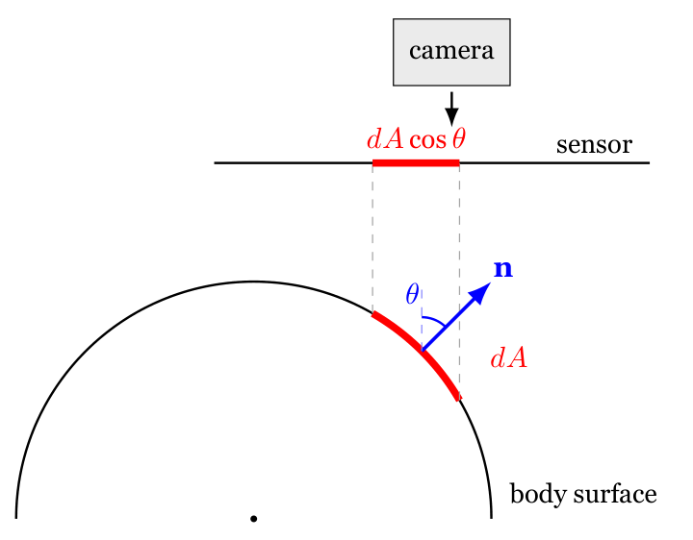
Figure 1. The principle of geometric underestimation by a 2D projection on a curved surface. The red arc is the true area of the patch dA on the body surface; the red segment on the sensor plane is its 2D projection dAcosθ. As the angle θ between the normal n and the optical axis grows, the projection shrinks, i.e., a 2D measurement systematically underestimates the true area.
For three-dimensionally curved anatomical regions — the foot, the shin, the heel — the angle $θ$ is not constant across the lesion: some surface points face the camera, others pass “beyond the horizon” of the surface. Therefore, the 2D area cannot be unambiguously corrected after the fact from a single image without additional information about the three-dimensional geometry [1,14]. In particular, the very same piece of skin captured from different viewpoints yields different area values, which makes correct comparison of lesion size over time impossible.
Empirical studies confirm the significance of this effect for skin lesions: in a direct comparison of 2D and 3D algorithms on phantoms, Mirzaalian et al. [16] recorded a relative error of the 2D method of $9.89±9.31$% versus less than 5% for 3D reconstruction from smartphone video. Chang et al. [17] showed that the 3D/2D measurement ratio on different body regions depends critically on curvature: $∼1.005$ on the back (flat), $1.641$ on the head and neck, and $1.908$ on the dorsum of the foot — that is, on the foot a 2D method captures only about half of the true lesion area.
Three-dimensional surface reconstruction removes this error by construction: given the recovered geometry, the area of the lesion region can be computed directly on the surface itself rather than on its projection. In a discrete polygonal-mesh representation this reduces to the sum of the areas of the individual triangles of the segmented subset (see Equation 2), and the resulting value is invariant to the position of the camera from which the images used to build the mesh were captured. The difference from 2D measurements becomes especially pronounced on strongly curved anatomical regions — precisely where the clinical need for accurate monitoring of wounds and skin lesions is most challenging to meet.

4.2 Mesh-based surface-area measurement
If the lesion region is represented by a set of triangles of a polygonal mesh, we compute its surface area as the sum of the areas of the individual triangles of the segmented subset $S$:
A=i∈S​Ai, | (2)
where the area of an individual triangle with vertices $v_{1},v_{2},v_{3}∈R^{3}$ is defined as half the magnitude of the cross product of two of its edges:
$$A_{i}=\frac{1}{2}|(v_{2}-v_{1})×(v_{3}-v_{1})|,$$ | (3)
The accuracy of the computed value $A$ depends on two independent error sources: (i) the geometric accuracy of the reconstruction itself, i.e., how well the mesh matches the true surface; (ii) the accuracy of selecting the subset S, i.e., the segmentation of the triangles belonging to the lesion region proper. In this work we focus primarily on evaluating the first error source.

4.3 Neus-Facto and neural implicit surface reconstruction
The fundamental difference between neural methods and classical photogrammetry is that the scene is represented not by a discrete set of points or triangles but by a continuous implicit function parameterized by a neural network. The overall input and output of such a pipeline — a set of frames with camera poses and the resulting textured mesh — are shown in Figure 2.
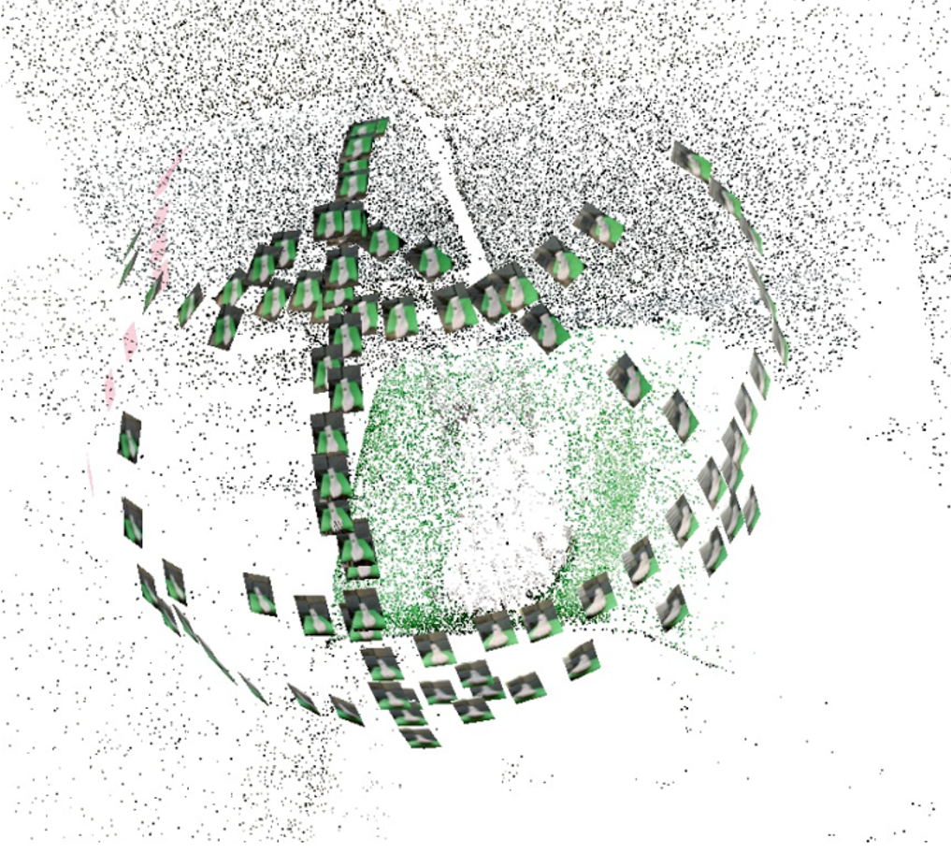 | 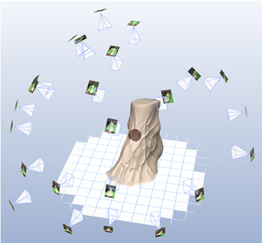
(a) The state after the SfM stage (COLMAP): a sparse point cloud and the frames placed at the estimated camera poses. | (b) After Neus-Facto training: the reconstructed textured mesh of the foot phantom at the center of the scene, with the frames at the estimated camera poses around it.
Figure 2. Input and output of the neural reconstruction: (a) the frames and the sparse point cloud in a common coordinate system after SfM (COLMAP); (b) the textured mesh as the final output of Neus-Facto.
The Neural Radiance Fields (NeRF) approach [18] was the first to show that a multi-view sequence of images can be represented by a function $(x,d)↦(c,σ)$ returning the color $c$ and volumetric density $σ$ at a three-dimensional point $x$ for a viewing direction $d$. An image from an arbitrary viewpoint is obtained by integrating density and color along a camera ray:
$$\hat{C}(r)=\int_{t_{n}}^{t_{f}}{T}(t) σ(r(t)) c(r(t),d) dt,$$ | (4)
where $T(t)$ is the accumulated transmittance of the ray up to depth $t$. The network parameters are optimized by gradient descent so that the generated images match the input ones. The rendering process for a single pixel is shown schematically in Figure 3: the camera ray is sampled at discrete points, and for each point the network returns color and density; the NeuS approach additionally restructures the density as a function of the distance from the zero-level set of the SDF, which concentrates the contribution precisely near the true surface.
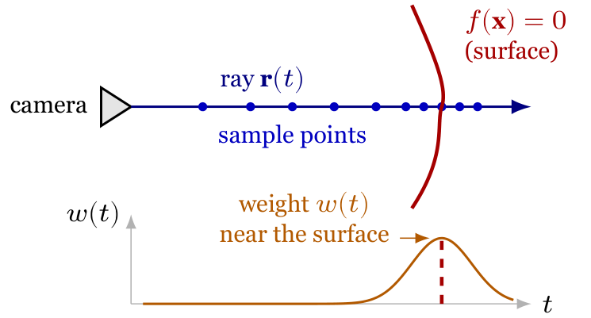
Figure 3. The principle of volumetric rendering of a single pixel in NeRF / NeuS. Top: the ray r(t) emanating from the camera is sampled at discrete points along depth; the predicted object surface is the zero-level set of the SDF, f(x)=0. Bottom: the weight profile w(t)=T(t) σ(r(t)) in the NeuS formulation is concentrated around the point where the ray intersects the surface; as a result, the integral (Equation 4) yields a color determined predominantly by the true surface rather than by a “smeared” volume.
Classical NeRF reproduces photorealistic renders well, but the resulting density function is a smooth volumetric shell from which extracting a crisp surface — for example, to compute an area — is difficult: one typically obtains “floater” artifacts (drifting clumps of density in empty space) and blurred contours. The NeuS approach [5] reformulated the density in terms of a signed distance function $f(x)$: points on the surface correspond to the zero-level set $f(x)=0$, and $σ$ is derived so as to be maximal precisely in the vicinity of this surface. This guarantees that the optimized density is concentrated on the surface rather than “smeared” through the volume; extracting an explicit mesh with the marching cubes algorithm [19] becomes a straightforward operation. Neuralangelo [6] added SDF curvature regularization, which made it possible to recover fine geometric detail at the cost of substantially longer training.
Neus-Facto is a faster variant of the NeuS family, implemented in the open-source SDFStudio framework [7] on the basis of architectural ideas from Nerfacto: a hierarchical ray-sampling strategy using a learned occupancy function (proposal sampler) and a more compact network architecture. This substantially shortens training time — from several hours to tens of minutes on a modern GPU — at the cost of somewhat lower geometric detail compared to Neuralangelo. Neus-Facto takes as input a set of images with camera-pose estimates (typically obtained via COLMAP/SfM), and outputs a three-dimensional mesh from which the area is computed directly via Equation 2. Empirical comparisons [1] show that within the SDF family Neus-Facto is particularly robust to a change of capture device, which partly motivates our choice of this specific variant.
Like all neural reconstruction methods, Neus-Facto is sensitive to input-data quality and hyperparameter selection. In particular, a lack of sufficiently distinctive visual features on the surface makes the SfM initialization of camera poses unreliable, which in turn degrades the final reconstruction as well; uneven angular coverage leads to asymmetric geometry quality, and the number of training iterations, the regularizer weights, and the export settings all affect the final mesh. We describe these practical aspects in detail in the “Materials and Methods” section and additionally assess their influence in the experimental part.

4.4 Capture geometry and depth of field
For close-up capture, depth of field decreases substantially as magnification grows. A simplified approximation common in macro photography [20] has the form:
$$DOF≈\frac{2Nc(1+m)}{m^{2}},$$ | (5)
where $N$ is the f-number, $c$ is the diameter of the circle of confusion, and $m$ is the linear magnification. In a regime close to macro photography, depth of field falls faster than the inverse square of magnification, which makes it difficult to keep the entire lesion region and the adjacent surface in focus simultaneously.
On the other hand, as the capture distance $s$ grows, the linear magnification $m$ decreases, and with it the spatial detail: a single sensor pixel covers a larger fragment of the physical surface. For a camera with focal length $f$ and pixel pitch $p$ (the size of an individual sensor cell), the size of the surface patch imaged into one pixel is approximately
$$d_{\text{pix}}≈\frac{p⋅s}{f},$$ | (6)
In photogrammetry this quantity is called the Ground Sample Distance (GSD) [21]; it directly limits the minimum size of detail that can be resolved in an image. For a typical smartphone lens ($f≈5$ mm, $p≈1$ µm) at a distance of $s=30$ cm we get $d_{\text{pix}}≈60$ µm, while at $s=1$ m it is already about $200$ µm; fine surface relief visible up close dissolves within a single pixel at a distance of a meter.
Together, Equation 5 and Equation 6 delineate a trade-off: as the distance $s$ increases, depth of field grows but detail degrades. A qualitative schematic interpretation of this effect is given in Figure 4: for close-up capture the in-focus zone is a narrow band covering only a fragment of the surface; for a more distant viewpoint the in-focus zone widens and holds the entire lesion region, but at too great a distance the lesion occupies too few pixels and loses detail.
The physical limitations of a smartphone sensor impose a second bound on this trade-off. Smartphone sensors typically have a diagonal of 5–10 mm, i.e., one to two orders of magnitude smaller than DSLR sensors; at the same relative aperture their total light throughput is substantially lower. In poorly lit conditions this leads to increased digital noise — stochastic variations in pixel brightness arising from photon shot noise and sensor read noise. Noise directly reduces the reliability of feature matching between frames at the SfM stage and manifests on the reconstructed mesh as local geometric artifacts. The effect is especially strong in shadowed regions, so capture should be performed in well-lit conditions or with an additional light source.
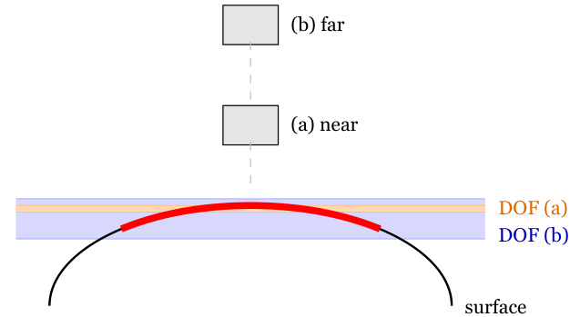
Figure 4. Schematic dependence of depth of field on capture distance. The black arc is the convex body surface; the red arc is the lesion region lying on that same surface (a segment of the same curve, redrawn in red). The narrow orange band is the in-focus zone for close-up capture (camera (a), high magnification m): only the apex of the surface is in focus, while the lateral parts of the lesion fall outside it. The wide blue band is the DOF for a more distant viewpoint (camera (b), lower m): it covers the entire lesion region at once. The trade-off cannot be pushed arbitrarily far, however: at too great a distance the lesion occupies too few pixels and loses detail.
A separate class of problems relates to exposure. Overexposure — exceeding the sensor’s dynamic range in bright regions — clips texture information in the brightest fragments: these regions lose their brightness gradients and become uniformly white, which for SfM matching is equivalent to a smooth, featureless surface. Underexposure, conversely, submerges fine gradients into the sensor-noise floor, so that informative details (micro-relief, subtle contrast) are lost. Optimally, exposure should be set so that the histogram touches neither of the extreme ends.

5. Materials and Methods

5.1 Phantom design
Evaluating Neus-Facto under conditions close to real clinical capture requires a physical object with a complex anatomical surface and an artificial lesion whose digital geometry is known in advance. The class of flat, barely raised skin lesions modelled here is illustrated in Figure 5.
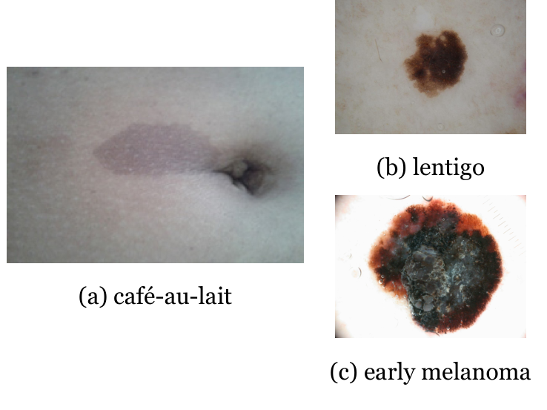
Figure 5. Examples of flat pigmented skin lesions: (a) a café-au-lait spot, (b) solar lentigo, (c) early melanoma. In all cases the lesion barely rises above the skin surface and follows its local relief. Image sources: (a) — reprinted from [22], licensed under CC BY 4.0; (b), (c) — ISIC Archive, images ISIC_0011293 [23] and ISIC_0000155 [24], licensed under CC0.
The phantom is based on an anatomically plausible 3D model of a foot [25] with pronounced surface curvature and the local relief of superficial veins (Figure 6).
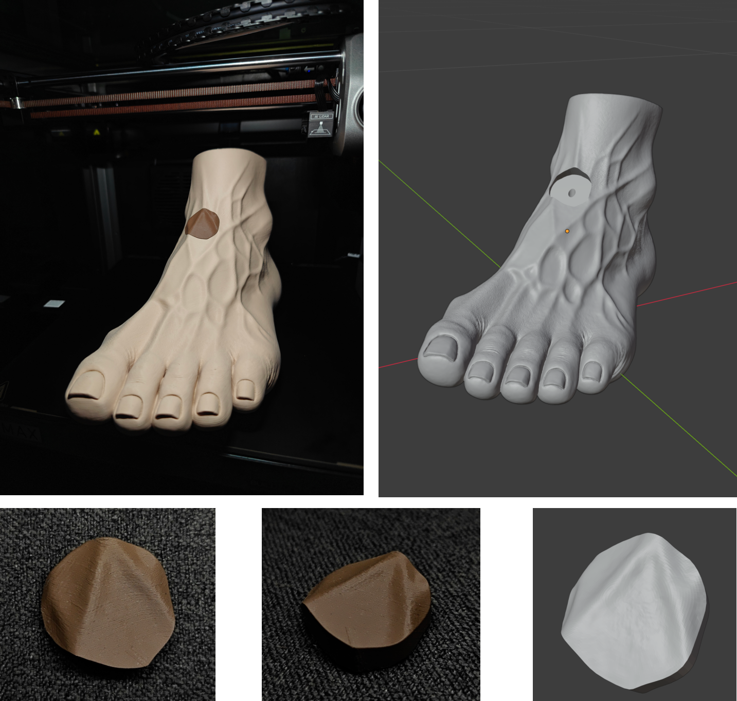
Figure 6. Design of the 3D-printed anatomical phantom. Top row: left — the printed foot phantom with the embedded lesion insert (the dark spot on the top of the foot), photographed inside the printer; right — a render of the digital CAD model of the same object from a similar viewpoint; the round recess on the top of the model is the slot into which the lesion insert is press-fitted. Bottom row: the separately printed lesion insert — left and center, two viewpoints of the real part; right — a render of the CAD model of the same insert.
The lesion region is located on the dorsum of the foot, slightly below the flexion point of the foot relative to the shin, over the tendons of the toe extensor muscles. This region is naturally slightly inclined (the surface descends smoothly from the ankle joint toward the metatarsal bones) and has pronounced overall curvature, yet relatively little local relief and a limited set of distinct visual features.
Such an anatomical region simultaneously simplifies and complicates the 3D reconstruction task. It simplifies it because the geometry here is smooth, without sharp depressions or protrusions, which reduces the risk of local reconstruction artifacts. It complicates it because SfM and neural reconstruction algorithms lack distinct local features (sharp lines, crisp relief, fine internal contrast) to “latch onto” for reliable matching between frames. The venous relief and the natural skin texture are the main source of such features here, whereas inside the lesion region itself there are no geometric details of its own — its surface follows the local relief of the foot.
The phantom is realized as a two-part assembly: the foot model with a slot for the artificial lesion, and a separate lesion insert mounted into this slot. This architecture cleanly separates the “lesion region” and the “surrounding anatomical surface” at the CAD-model level, while after physical assembly the insert geometrically continues the local shape of the foot. This makes it possible to unambiguously identify the lesion region for computing the reference area without introducing artificial relief that could make the reconstruction algorithm’s task easier.
The lesion contour was defined in Blender as a closed curve on an auxiliary plane and then projected onto the surface of the foot model by ray intersection with the polygonal mesh. From the resulting projection we formed a surface patch that exactly follows the local curvature and relief of the foot within the lesion. The volumetric insert element was built from the same region: the top surface of the insert corresponds to the projected patch of the foot, and the interior volume is formed by extrusion into the model. The corresponding slot in the foot model was cut with a Boolean operation; to allow physical installation of the insert after FDM printing, the slot has a small assembly clearance, and an auxiliary channel for pushing the insert out was added on the inner side (it does not belong to the analyzed external surface of the phantom).
Importantly, the lesion region has no relief of its own — its top surface merely follows the anatomical contour of the foot. This choice models the class of skin lesions that barely rise above the skin surface and essentially follow its contour: for example, flat pigmented lesions (in particular, early forms of melanoma, solar lentigo, or café-au-lait spots) or superficial vascular malformations such as port-wine stains. In this setting the 3D reconstruction task is positioned as one in which the algorithm cannot rely on local geometric features of the lesion itself for its identification; everything takes place within a uniformly smooth anatomical surface. Owing to the specifics of FDM printing, the seam between the insert and the main model may be visually noticeable as a thin line on the surface, but the design itself is engineered to minimize the geometric discontinuity at this location.

5.2 3D printing and reference geometry
The physical phantom was fabricated by FDM/FFF printing on a Creality K1 Max printer from matte PLA filament (Polymaker Panchroma Matte, CA04007). Slicing was done in Creality Print; to preserve fine surface detail, a layer height of 0.08–0.12 mm was used with a 0.4 mm nozzle diameter, two perimeter walls, and roughly 8% infill. Supports were applied only where the geometry required them; to reduce the risk of the large part detaching from the bed, brim-type edge adhesion was used.
The reference geometry of the lesion region is computed directly from the digital CAD model of the surface patch corresponding to the top surface of the insert, without any physical measurement on the printed object. The area is determined via Equation 2 as the sum of the areas of the triangles of this surface. The resulting value serves as the direct reference for subsequent comparison with the results of 3D reconstruction from smartphone capture.
Between the digital model and the physically printed phantom there remains the fabrication error of FDM printing. For the Creality K1 Max under proper calibration (including the built-in LiDAR bed calibration) it is expected to lie in the sub-millimeter range, but it is not measured metrologically here. This is a limitation of our approach, which future work may refine through an independent measurement of print accuracy.

5.3 Smartphone capture protocol
Images were captured with the main camera of a OnePlus 13 — a modern consumer-grade smartphone. The capture protocol aims to reduce motion blur, focus instability, exposure variation, shadows, and background influence. The capture trajectory is shown schematically in Figure 7.
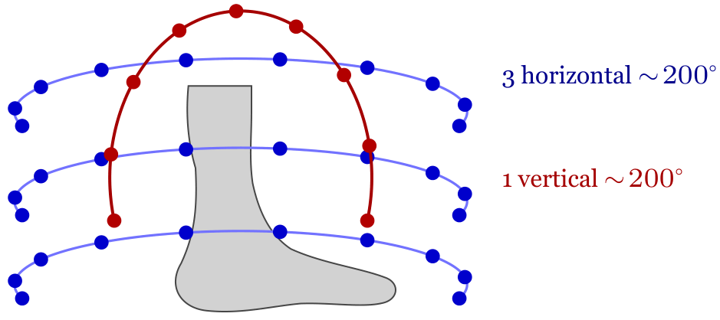
Figure 7. Schematic of the recommended capture trajectory. Three horizontal circular orbits (blue) at different heights, each spanning roughly 200° around the object. One vertical orbit (red) of roughly 200° from the bottom up and over the apex; a full 360° is impossible because the adjacent anatomical part of the body occludes part of the camera sphere. Dots mark individual frame positions.
Figure 8 shows an example frame from a real capture session.
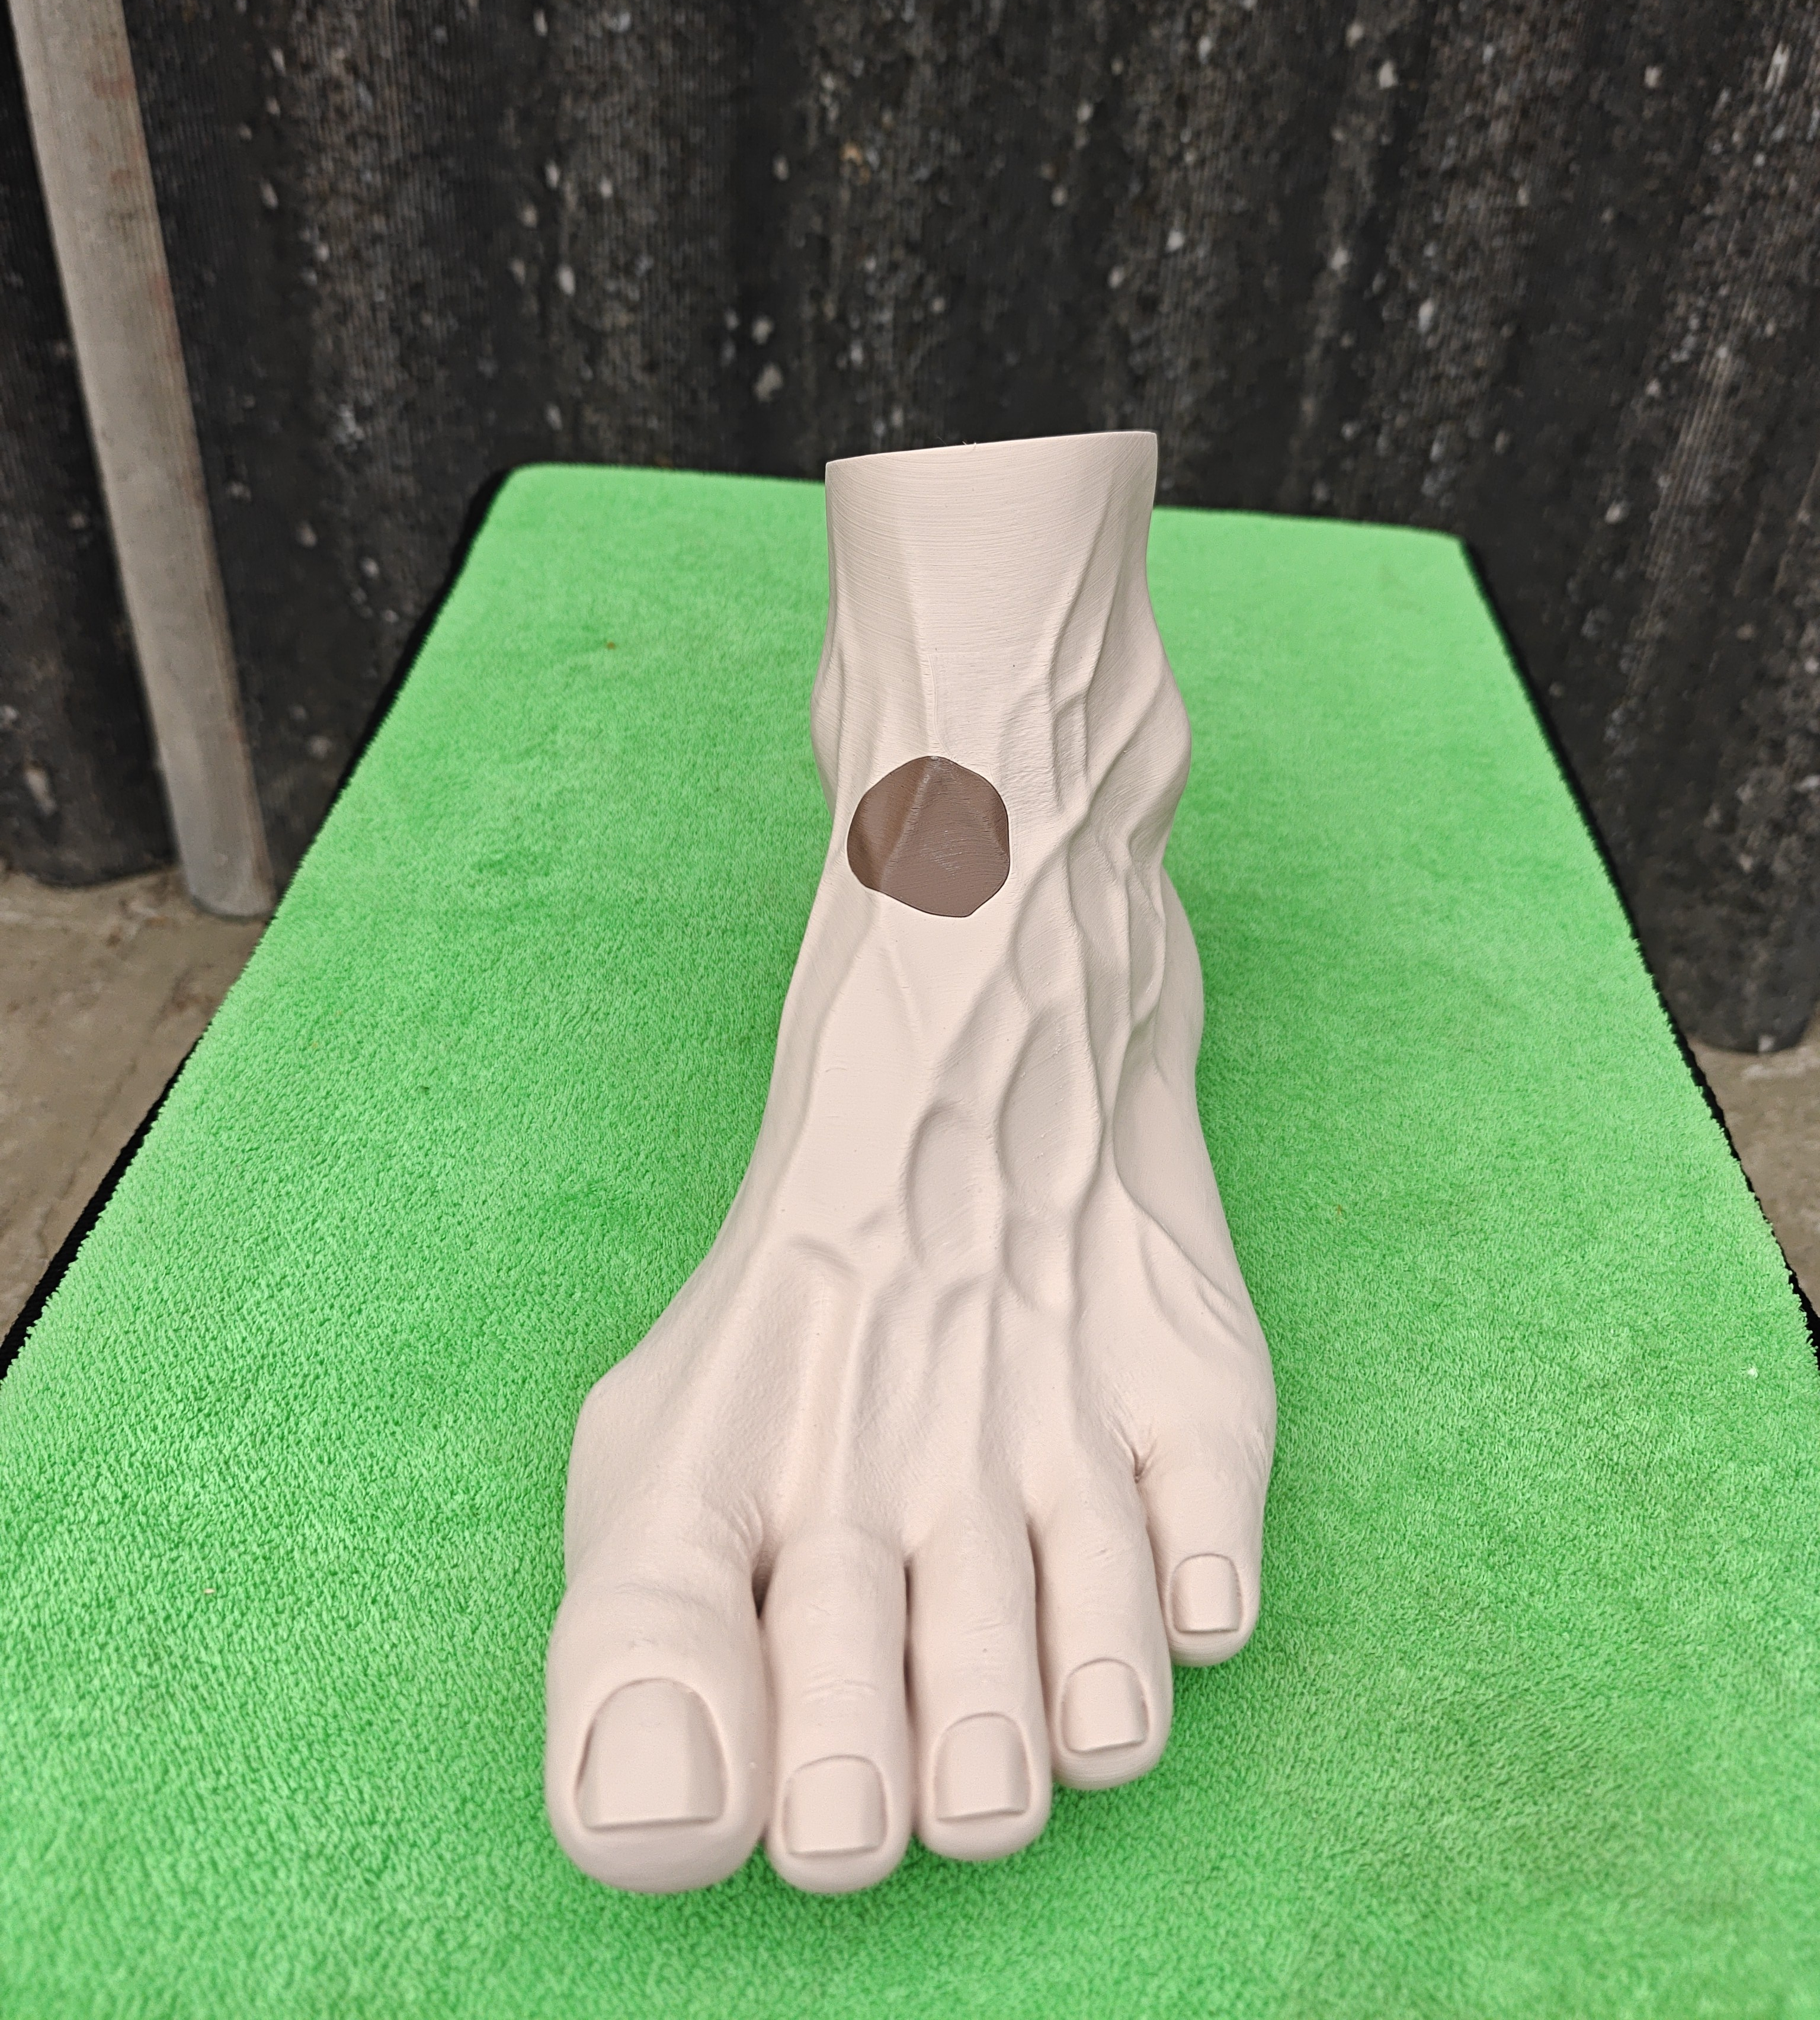
Figure 8. An example frame from a real phantom capture session: a viewpoint from one of the horizontal orbits, with the lesion region fully in focus.
The choice of capture distance deserves separate attention. Equation 5 shows that depth of field falls faster than the inverse square of magnification — in our case this manifests directly as a trade-off between completeness of focus and surface detail. Figure 9 shows the same viewpoint of the phantom’s lesion region captured from two slightly different distances. At the shorter distance (a) the lesion region occupies more pixels and conveys the surface micro-relief more crisply, but the depth of field proves insufficient to simultaneously keep the entire lesion area together with the adjacent anatomical surface in focus: parts of the region already fall outside the sharp range. Moving slightly farther away (b), the entire lesion region lies fully in focus, but detail per unit of surface area drops because fewer pixels cover the same patch.
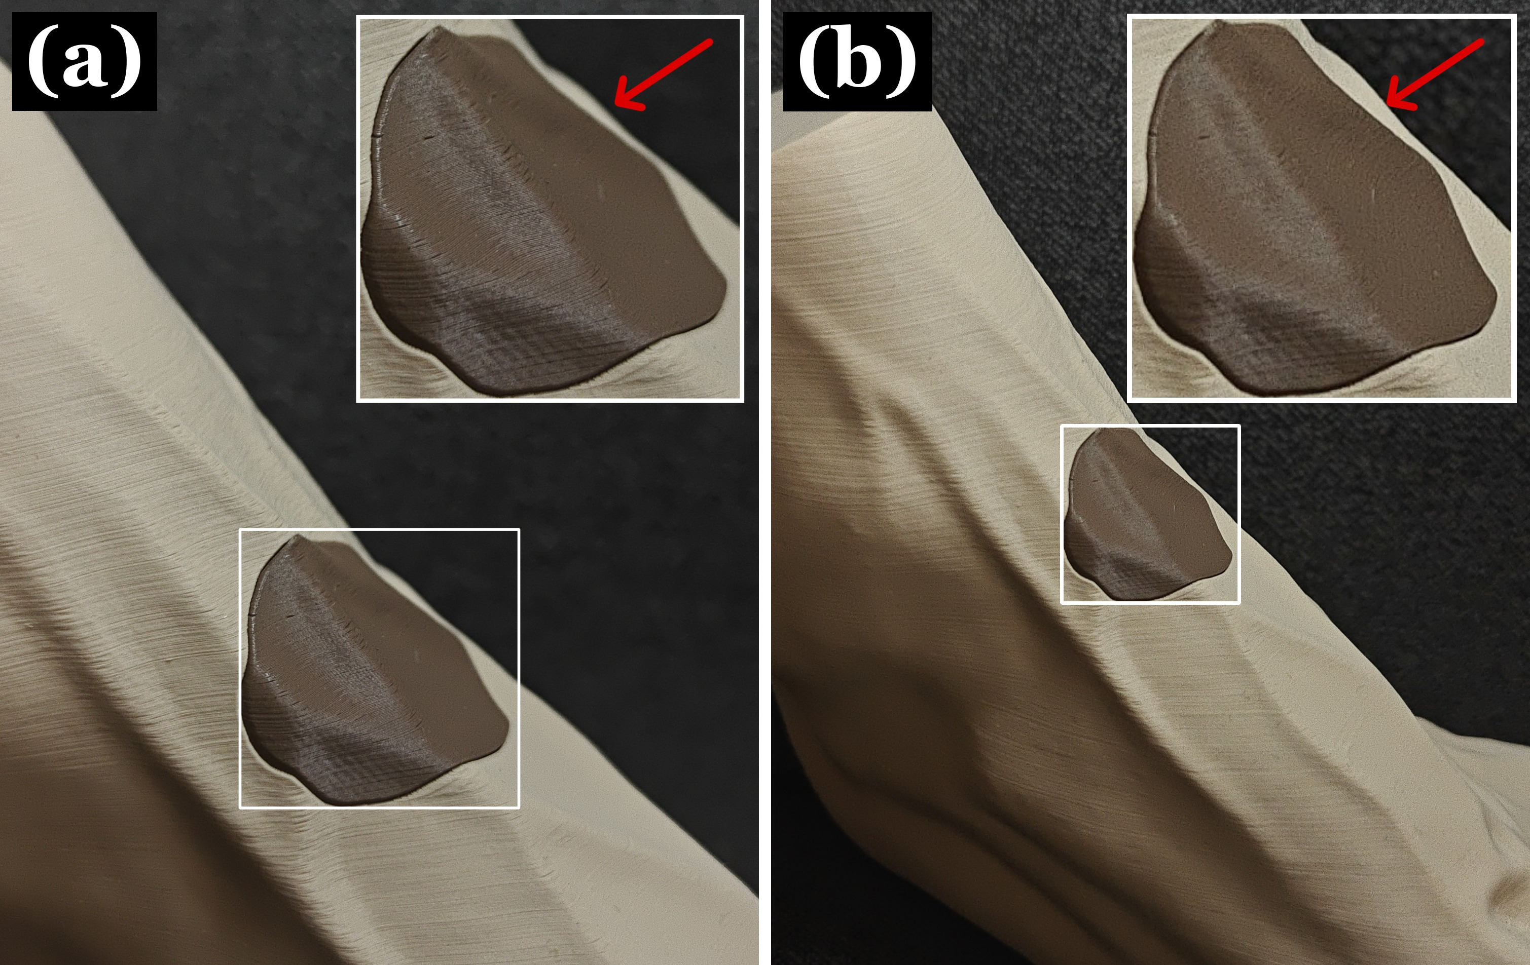
Figure 9. The depth-of-field versus detail trade-off when capturing the lesion region. (a) Capture from a shorter distance: the lesion region occupies more pixels and conveys the surface micro-relief better (the trace of the print layers is visible), but parts of the region fall outside the depth of field. (b) The same viewpoint from a slightly greater distance: the entire lesion region lies fully in focus, but detail per unit of surface drops. The corner insets in each panel are identically scaled crops of the marked lesion area for direct comparison.
The choice is further complicated by the fact that the geometry of the body region on which the lesion is located additionally constrains both the admissible distances and the available viewpoints: capturing from arbitrary angles and arbitrary distances is impossible, since the adjacent anatomy occludes part of the spherical camera coverage. The capture protocol therefore selects the minimum admissible distance at which the entire lesion region, together with a sufficient margin of the adjacent surface, stably lies within the depth of field, without an excessive sacrifice of detail.
Angular coverage of the object is provided by a trajectory consisting of three horizontal circular orbits at different heights (from a slightly higher, a middle, and a lower viewpoint), each spanning roughly ${200}^{∘}$ around the region of interest, and one vertical orbit of roughly ${200}^{∘}$ — from below the object upward and over the apex. The vertical orbit fundamentally cannot be a full ${360}^{∘}$, since the adjacent anatomical part of the body (in our case, the shin model) occludes part of the spherical camera coverage from below. This combination of orbits provides sufficient angular overlap of the surface from all sides and compensates for self-occlusions on curved anatomical regions.
The final quality of the 3D reconstruction is determined by the balance of three interrelated factors: depth of field and pixel-level detail (discussed above), sufficient angular coverage of the lesion region, and correct exposure without extremes. The specific requirements for an individual frame can be formulated as follows:
- Exposure — stable across frames, with no overexposed “washed-out” areas and no shadows sinking into the sensor noise (see Section 4.4 in the theoretical part for the rationale).
- Lighting — as uniform and constant across frames as possible; avoid sharp shadows from the operator’s hands or body or from moving light sources, since every such shadow moves together with the camera and shows up in SfM as an artifact of inconsistent illumination of the same point in different frames.
- Focus — locked so that the entire lesion region and a sufficient margin of the adjacent surface lie within the depth of field; where possible, by locking the focus point before starting a circular orbit to avoid re-autofocus between frames.
- Motion — minimize camera shake at the moment of exposure and, in clinical conditions, motion of the patient or the body part; any displacement between the exposure and the actual moment of photographing distorts the SfM camera-pose estimate.
- Specular highlights — avoid bright local highlights from moist or glossy surface areas; if necessary, use a polarizing filter or soft diffuse lighting. Highlights move together with the camera and are not a property of the surface, so SfM treats them as contradictory information between frames.
- Background — preferably static and distinct in texture/color from the region of interest, so that the algorithm does not confuse background features with object features.
- Angular coverage — a sequential orbit of the region with sufficient overlap of neighboring frames (typically 60–80%) and sufficient angular spread, so that the entire visible part of the surface is captured from several viewpoints and lends itself to triangulation.

5.4 Reconstruction pipeline
Reconstruction is performed in the open-source SDFStudio framework [7]. It combines the COLMAP camera-pose estimation stage [26] with neural surface reconstruction by methods of the SDF family, among which we use Neus-Facto.
At the structure-from-motion (SfM) stage, COLMAP detects and matches local features between frames and then jointly estimates the camera extrinsics (4×4 c2w pose matrices), the intrinsics (focal length, principal point, radial and tangential distortion coefficients of the OpenCV model), and a sparse cloud of three-dimensional points via bundle adjustment. The camera intrinsics are the result of joint estimation, not of external calibration; the solution is self-consistent up to a global similarity (scale and origin are arbitrary). The SfM results are written to a transforms.json file in a format compatible with nerfstudio/SDFStudio.
At the neural reconstruction stage, the Neus-Facto model is trained to minimize the photometric discrepancy between the frames predicted by differentiable volumetric rendering and the real images. For our setup the following key hyperparameters were determined empirically:
- Number of iterations — 80,000. Smaller values (15–60k) leave the geometry under-trained (noticeable cloudy artifacts near the surface), while further increases (to 100–200k) yield only marginal improvement at the cost of training time.
- Ray batch size — 8192 (train_num_rays_per_batch). This is the standard and, for our setup, optimal value, maximizing the signal per iteration.
- Rendering range — near_plane $=0.01$ and far_plane $=5.0$ in internal scene units (overwrite_near_far_plane = true). These values define the depth interval along each ray within which SDF points are sampled: points closer than near or farther than far are ignored. A small near guarantees that a surface that may end up close to the camera will not be “clipped”, while a moderate far removes the contribution of the empty background behind the object, which would otherwise waste network capacity on useless rays.
Two regularizers deserve separate attention, having proven the most sensitive to the specific capture session — the eikonal loss multiplier (eikonal_loss_mult) and the initial SDF bias (sdf_field.bias).
Eikonal regularization adds to the loss function a term proportional to the squared deviation of the gradient norm $\left\|∇f\right\|$ from unity at the training samples. This is a fundamental property of a true signed distance function; without such regularization the network can learn a “soft” field that renders correctly but loses the crisp geometric meaning of the zero-level set. A larger coefficient yields a smoother and metrically more correct SDF but limits the model’s ability to capture fine detail; a smaller one leaves more freedom for detail but raises the risk of local noise artifacts.
The initial SDF bias sets the radius of the implicit sphere to which the network is initialized at the start of training (geometric_init = true): the value $f(0)$ equals $-\text{bias}$, i.e., the scene origin lies inside the surface at distance bias from its zero-level set. A larger value corresponds to a larger initial sphere, which helps when the object occupies a large part of the scene; a smaller one — when the object is compact and centered.
Empirically, two stable combinations of these parameters were found for our phantom, depending on capture distance. For sessions where the lesion region occupied a larger part of the frame (close-up), the pair $0.1/0.1$ was optimal: the denser photometric signal tolerates weaker regularization, and the compact initial sphere matches the object occupying most of the scene’s bounding volume. For sessions from a somewhat greater distance (the lesion occupied fewer pixels), the pair $0.5/0.5$ was better: the strengthened regularization compensates for the poorer signal and prevents overfitting to sensor noise, while the larger initial sphere radius better matches a scene in which the object occupies only a small fraction of the total volume. The other tested grid points — $0.1/0.5$, $0.5/0.1$, as well as extreme bias values ($0.01$, $1.0$, $2.0$) — gave systematically worse results in either smoothness or detail.

5.5 Mesh export and scaling
The output of training is the model weights, not an explicit mesh; converting the SDF into a triangulated surface is a separate export stage, for which we used the maximum detail settings available in SDFStudio.
Surface extraction is performed with the marching cubes algorithm [19] on a regular voxel grid of resolution ${4096}^{3}$. A higher resolution allows the SDF zero-level set to be localized more precisely on fine details, but the raw mesh size grows rapidly — the direct output at ${4096}^{3}$ contains about ${10}^{8}$ triangles, which is practically unusable for either storage or further processing.
Mesh simplification is performed immediately after extraction: the target triangle count is capped at ${10}^{6}$ (1M faces), which preserves geometric accuracy at a level sufficient for the subsequent lesion-area analysis, at a markedly smaller data volume. Simplification uses the quadric edge collapse method [27], which minimizes the local deviation of the new surface from the original.
Texturing is done by projecting the learned colors of the SDF field onto a UV unwrap of the resulting mesh at a resolution of $8192×8192$ pixels ($8$K). This texture resolution substantially exceeds the real detail of the input frames and is effectively a “soft ceiling” — it guarantees that visual quality is not limited by texture size; the effective detail remains limited by the quality of the capture itself and by the angular coverage.
The output is a textured mesh in .obj (with the corresponding .mtl file) and .glb formats, together with the UV unwrap as texture.png. At this stage the geometric coordinates remain in internal scene units, not millimeters: SfM reconstructs the object up to a global similarity, so the metric scale must be recovered separately. In our setup it is not introduced via an external calibration object in the frame but is derived directly from the reference CAD geometry at the evaluation stage — discussed in more detail in the corresponding section.

5.6 Lesion region extraction and segmentation
The lesion region on the surface of the reconstructed 3D mesh is extracted automatically by fusing segmentations from several viewpoints directly on the three-dimensional mesh itself. Segmentation is performed not on the original frames but on renders of the exported textured 3D mesh from the same camera poses: the baked texture removes frame-to-frame lighting variation and gives a consistent color of the lesion region across all viewpoints.

5.6.1 Per-frame segmentation
On each render, the BiRefNet model [28] first separates the foot from the background, and then the general-purpose SAM 3.1 model — from the Segment Anything family [29] — extracts the lesion region itself from a text prompt. The segmentation quality of these models is extremely high and is not a bottleneck of our pipeline. The predicted masks additionally pass a short post-filter on size and mean color in LAB space to remove occasional false positives.

5.6.2 Vote aggregation in 3D space
The masks from all $N$ renders are fused in three-dimensional space. To increase spatial resolution, the mesh is first densified by Loop subdivision [30]. Each triangle of the 3D mesh receives a normalized score $s$ as the weighted mean of the votes from all viewpoints in which it is visible, with weight $\cos^{3}θ_{v}$ (where $θ_{v}$ is the angle between the triangle normal and the ray toward the camera of frame $v$). This weight strongly suppresses the contribution of votes from grazing-angle viewpoints, where the centroid projection is less reliable. Triangles with $s≥0.9$ are marked as candidates for lesion membership.
The overall structure of the processing pipeline — from smartphone capture through lesion-region extraction to comparison with the reference geometry — is shown in Figure 10.
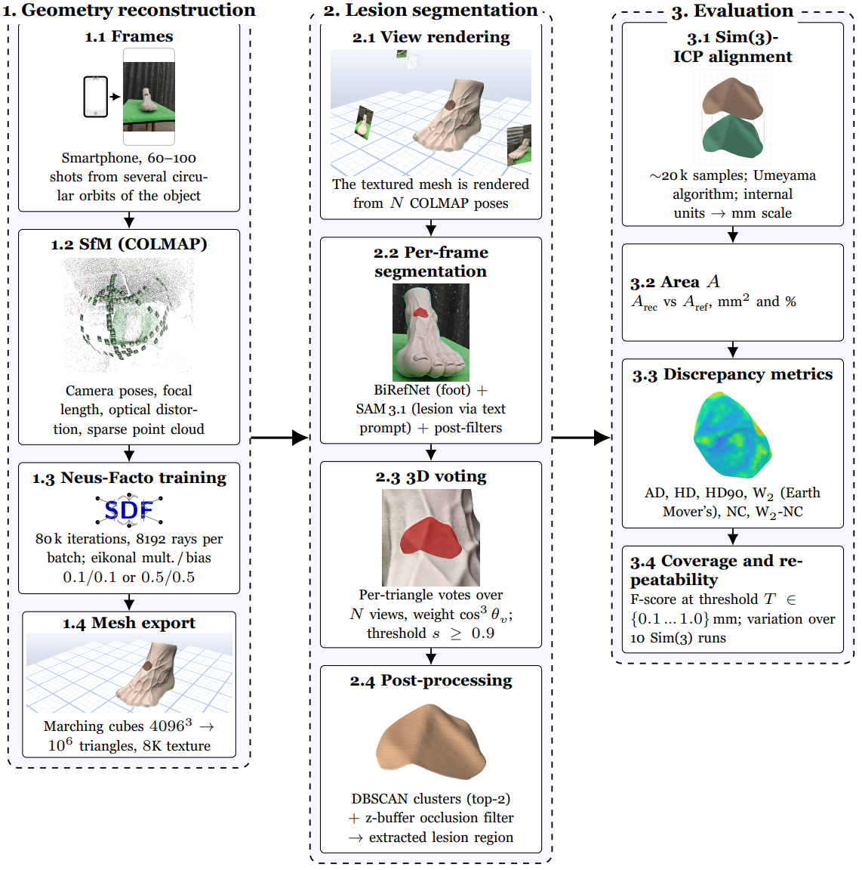
Figure 10. Overall pipeline schematic. Block 1 reconstructs the three-dimensional geometry of the foot surface from smartphone capture: SfM estimation of camera poses in COLMAP, neural SDF training with Neus-Facto, export of the textured mesh. Block 2 automatically extracts the subset of mesh triangles belonging to the lesion region by multi-view fusion of 2D segmentations directly on the mesh itself. Block 3 compares the extracted subset with the reference CAD geometry constructed in section 5.2: estimation of the scale from internal reconstruction units to mm via Sim(3)-ICP, computation of the region area in mm$​^{2}$ and of the geometric discrepancy metrics (AD, HD, HD90, $W_{2}$, NC, $W_{2}$-NC, F-score at threshold $T$), and assessment of the algorithm repeatability over 10 repeated ICP runs.

5.6.3 Post-processing: spatial clustering and occlusion filtering
From the initial candidate set we remove (i) isolated triangles that passed the threshold due to occasional false positives on edge frames, and (ii) triangles that formally project into the masks but are actually hidden behind another part of the surface.
The first filter is the DBSCAN algorithm [31] with $ε=8⋅d_{\text{med}}$, where $d_{\text{med}}$ is the median distance between neighboring centroids. Of the resulting clusters we keep the two largest: this guarantees robustness to cases where the main body of the lesion is topologically split by a thin gap in the mesh.
The second filter uses a z-buffer: for each candidate we check whether its centroid is indeed the surface closest to the camera at the point of its projection. If a triangle passes the geometric visibility check but the z-buffer shows another surface in front of it (i.e., it “shows through” the outer shell), it is discarded. In practice this removes inner-shell SDF artifacts, which can form in Neus-Facto through double reconstruction of a surface from both of its sides. Candidates visible in fewer than $30 \%$ of frames under this test are removed.
The final result is the subset of triangles $S$ corresponding to the lesion region on the surface of the reconstructed 3D mesh.

5.7 Area computation
The area of the reconstructed lesion region is computed directly as the sum of the areas of the individual triangles of the subset S via Equation 2 (an example of the triangulated surface is shown in Figure 11), without any additional smoothing or approximation of the lesion boundary itself. Boundary triangles — those lying on the very edge of the region — are taken whole: a passive extension of the boundary by half a triangle inward from the contour is the same source of systematic error as an active extension outward, so these effects average out over the large number of triangles on the boundary and do not shift the final value noticeably at our discretization level (∼ 10⁶ triangles on the foot; with ×2 subdivision — ∼ 1.6⋅10⁷ during voting).
The resulting value A_{rec} is expressed in internal (recon) scene units, not in millimeters. Conversion to millimeters happens at the evaluation stage — simultaneously with the estimation of the other geometric metrics of the reconstruction’s discrepancy from the reference.
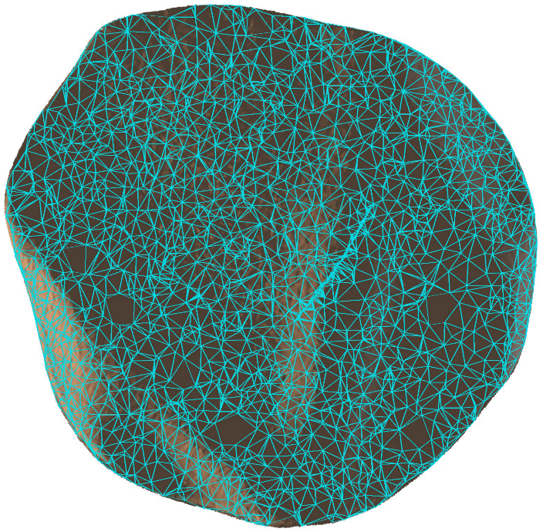
Figure 11. The triangulated surface of the lesion region.

6. Experiments

6.1 Accuracy against a known reference
Accuracy is defined as the distance between the reconstructed lesion region and its CAD reference after alignment into a common metric coordinate system via Sim(3)-ICP with the Umeyama algorithm [32], as implemented in the Open3D library [33]. For each run the full set of geometric discrepancy metrics is computed: AD (mean NN distance, mm), HD (Hausdorff, mm), HD₉₀ (90th percentile of NN distances, mm), W₂ (2-Wasserstein, Earth Mover’s [34], computed via the POT library [35], mm), NC (normal consistency over NN pairs), W₂-NC (normal consistency under the W₂ coupling), the area difference in mm² and in percent relative to the reference, the conversion factor from internal units to mm, and the F-score at thresholds T ∈ {0.1; 0.2; 0.3; 0.5; 0.7; 1.0} mm [36].
Sim(3)-ICP is run with PCA initialization of the orientation over 16 candidates (2³ sign combinations of the coordinate axes × two permutations of the PCA axes) and a maximum correspondence distance capped at 0.5 mm. Without such initialization, standard Sim(3)-ICP collapses into a local minimum on some of our runs through scale shrinkage. The PCA initialization places ICP already in the vicinity of the correct orientation, after which the reduced correspondence distance prevents boundary outliers from being absorbed by scale shrinkage.
The area of the reconstructed region after the Sim(3)-ICP transformation into mm coordinates is computed as the sum of the areas of its triangles (Equation 2) and compared directly with the reference value A_{ref} = 814.18 mm² computed from the corresponding fragment of the CAD model.

6.2 Repeatability across capture sessions
Repeatability is defined as the spread of the metrics over a set of repeated independent physical capture sessions of the same phantom. Each session is a separate photographic capture of the phantom at a different time, with slightly different viewpoints; for each session, COLMAP SfM, Neus-Facto training from scratch, and all subsequent segmentation and evaluation stages are re-run. This setup differs from the “inter-recording precision” of SALVE [1], where the “repeats” comprise different frame subsamples of one and the same video — such a spread characterizes the algorithm’s robustness to input subsampling rather than the repeatability of the full capture-to-mesh pipeline. Independent physical sessions additionally expose sources of variation that subsamples of a single recording fundamentally cannot cover: changes in lighting, slightly different viewpoints between sessions, re-estimation of the COLMAP intrinsics, and the random initialization of Neus-Facto.
To assess repeatability, 10 independent capture sessions of the phantom were conducted, each processed end-to-end. Over the set of 10 runs we compute the mean, the standard deviation σ (with Bessel’s correction), the min–max range, and the coefficient of variation CV=σ/μ for each metric.

7. Results
The main metrics were computed over 10 independent capture sessions of the phantom, processed end-to-end with the described pipeline.

7.1 Accuracy
Table 1 presents the full set of discrepancy metrics for each of the 10 runs.
Table 1. Discrepancy metrics for 10 independent capture sessions of the same phantom. A is the measured region area after Sim(3)-ICP; ΔA is the relative deviation from the reference Aref = 814.18 mm².
№ | AD (mm) | HD (mm) | HD₉₀ (mm) | NC | F1@0.3 | F1@0.5 | A (mm²) | ΔA
1 | 0.162 | 0.659 | 0.258 | 0.9900 | 96.3% | 99.9% | 827.7 | +1.67%
2 | 0.121 | 0.751 | 0.194 | 0.9854 | 99.3% | 99.9% | 833.1 | +2.32%
3 | 0.148 | 0.683 | 0.246 | 0.9919 | 95.9% | 99.9% | 823.0 | +1.08%
4 | 0.132 | 0.679 | 0.211 | 0.9866 | 99.2% | 99.9% | 834.6 | +2.51%
5 | 0.115 | 0.833 | 0.188 | 0.9801 | 99.3% | 99.8% | 838.9 | +3.04%
6 | 0.118 | 0.870 | 0.194 | 0.9907 | 99.1% | 99.8% | 833.9 | +2.43%
7 | 0.115 | 0.764 | 0.189 | 0.9921 | 99.2% | 99.8% | 826.6 | +1.53%
8 | 0.118 | 0.731 | 0.191 | 0.9906 | 99.4% | 99.9% | 825.7 | +1.41%
9 | 0.114 | 0.811 | 0.185 | 0.9879 | 99.3% | 99.8% | 831.9 | +2.18%
10 | 0.114 | 0.881 | 0.188 | 0.9837 | 99.1% | 99.7% | 838.6 | +2.99%
AD — the mean bidirectional NN distance between the surfaces — lies in the range 0.114–0.162 mm (i.e., below 0.25 mm for all 10 runs), and HD₉₀ in the range 0.185–0.258 mm. The worst-case Hausdorff distance HD, corresponding to the single most distant point pair, lies within 0.659–0.881 mm. The F-score at a 0.3 mm threshold stays at no less than 95.9%, and the F-score at a 1.0 mm threshold at 100% on all 10 runs. The measured area of the region lies in the range 823.0–838.9 mm² against the reference value A_{ref} = 814.18 mm² — a systematic area overestimate of +1.08% to +3.04%; no run yields a negative bias.

7.2 Repeatability
Table 2 presents the mean, standard deviation, min–max range, and coefficient of variation CV for the main metrics over the set of 10 runs. The most meaningful for clinical application is the repeatability of the measured area: $σ_{A}=5.46$ mm² (CV $=0.66$%). This means that for a region of reference area $≈814$ mm², the full capture-to-mesh pipeline reproduces the measured value to within $±5.5$ mm² (one standard deviation) across repeated physical capture sessions. The standard deviation of AD is $σ_{\text{AD}}=0.017$ mm; the standard deviation of HD₉₀ is $σ_{{\text{HD}}_{90}}=0.026$ mm — likewise at the level of tens of microns.
Table 2. Repeatability of the metrics across 10 independent capture sessions. CV is the coefficient of variation σ/μ.
Metric | μ | σ | min–max | CV
AD (mm) | 0.126 | 0.017 | 0.114–0.162 | 13.3%
HD (mm) | 0.766 | 0.080 | 0.659–0.881 | 10.5%
HD₉₀ (mm) | 0.204 | 0.026 | 0.185–0.258 | 12.9%
A (mm²) | 831.40 | 5.46 | 823.0–838.9 | 0.66%
ΔA | +2.12% | 0.67% | +1.08–+3.04% | —
F1@0.3 (mm) | 98.60% | 1.32% | 95.88–99.36% | 1.3%
F1@0.5 (mm) | 99.85% | 0.07% | 99.73–99.94% | 0.07%
NC | 0.9879 | 0.0039 | 0.980–0.992 | 0.4%
Figure 12 presents the F-score as a function of the distance threshold across all 10 sessions, complementing the aggregate values reported in the tables above.
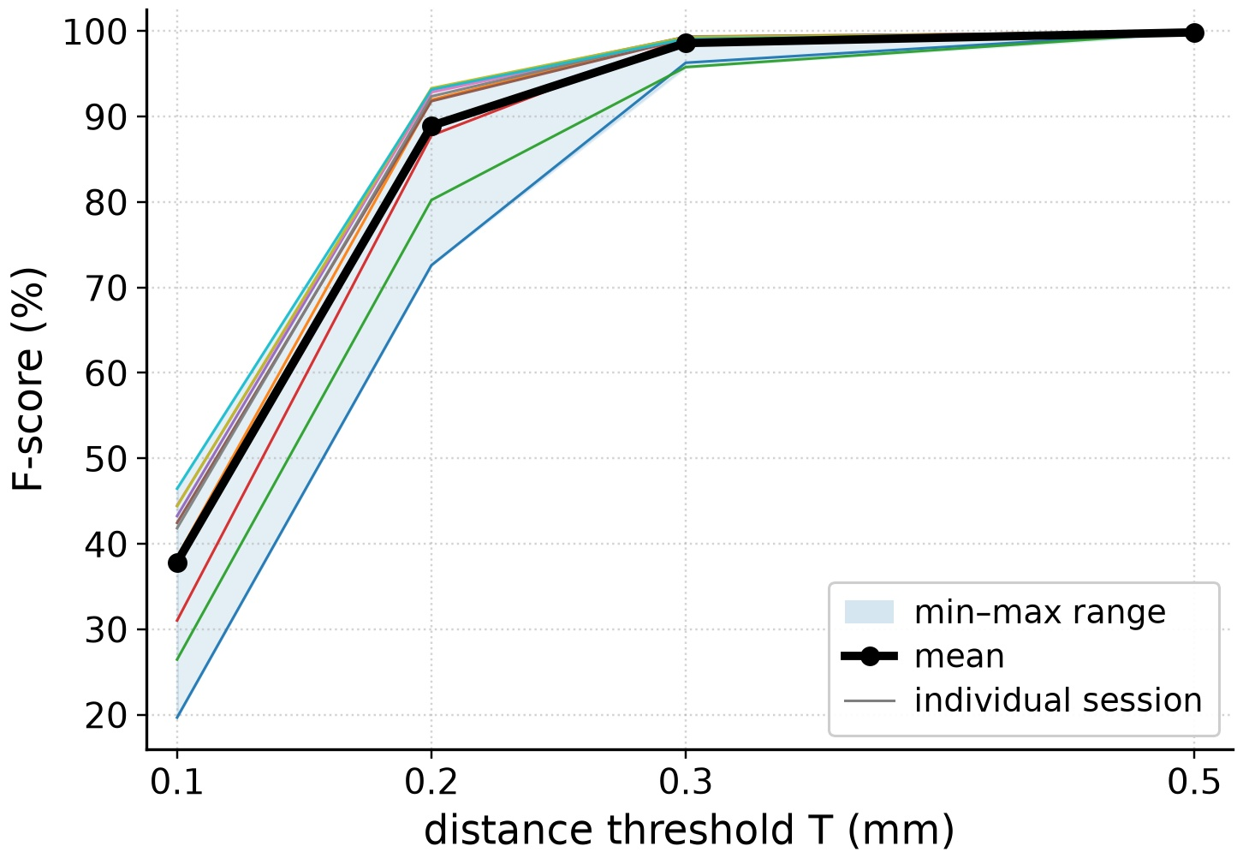
Figure 12. F-score as a function of the distance threshold T across 10 independent reconstruction sessions. Thin lines — individual sessions, bold black — the mean, light-blue band — the min–max range. Line colours match the run colours in Table 1.

7.3 Visual comparison of reconstructions
Figure 13 visualizes the metric tables: visually, the entire sample of 10 runs is practically interchangeable at a typical viewpoint and scale of the lesion region.
Figure 13. Mosaic of the 10 runs (plus the reference photo and the segmentation mask in the first two cells) in a common viewpoint. Each reconstruction is projected through the same COLMAP camera of one of the reference frames and with the lesion region at the same scale, so the runs are directly comparable visually. Differences between runs in this view are barely perceptible to the naked eye.

7.4 Distance map to the reference
Figure 14 juxtaposes the heat maps of the best and worst runs by AD from our sample.
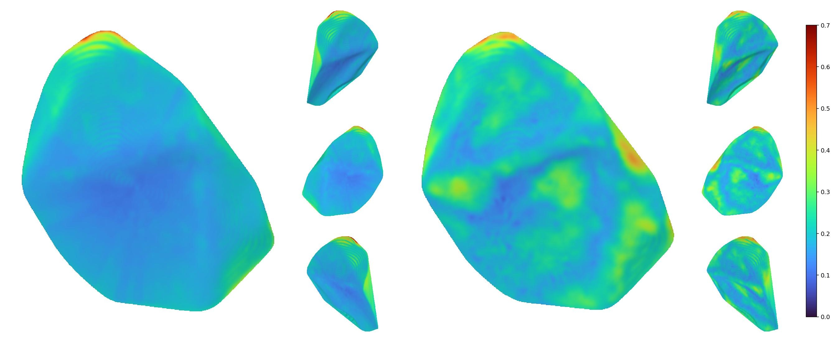
Figure 14. Heat maps of distances from the reconstructed surface to the reference CAD geometry. Left — the run with the best AD in our sample; right — the worst. Blue is a small distance to the reference ($∼0$ mm), red is larger. Even for the worst run, the overwhelming majority of the surface deviates from the reference by less than $0.3$ mm; the locally brighter zones correspond to the region boundary (where segmentation can vary by 1–2 pixels) and to one small area over the tendons of the toe extensor muscles.
The zones where deviations from the reference exceed $0.3$ mm concentrate mostly on the boundary of the lesion region (where pixel-level segmentation uncertainty naturally arises) and in one small subregion over the tendons of the toe extensor muscles. The rest of the surface, even for the worse run, is reproduced with an error below what can be visually distinguished at the chosen scale.

8. Discussion

8.1 Interpretation of results
The AD metric (mean bidirectional NN distance between the surfaces) shows by how much, on average, the reconstructed surface of the region deviates from the reference CAD surface at each of its points. It is the basic characteristic of the geometric quality of the reconstruction: it sets a lower bound for any further derived measurements. The obtained AD $=0.114$–$0.162$ mm is below a millimeter on all 10 runs.
The error of the measured area itself, $+1.08$–$+3.04$%, is a derived metric that integrates the geometric inaccuracy of the reconstruction with the inaccuracy of automatic segmentation; it lies well below clinically meaningful changes in lesion area during monitoring over time.
The repeatability of the measured area, $σ_{A}=5.46$ mm$​^{2}$ (CV $=0.66$%), on a plastic phantom whose area does not physically change, is the pure spread introduced by the capture-to-mesh pipeline itself. The box plots of the main metrics are shown in Figure 15. The size of this spread is substantially smaller than a typical clinically meaningful change in the area of a real lesion over the course of monitoring.
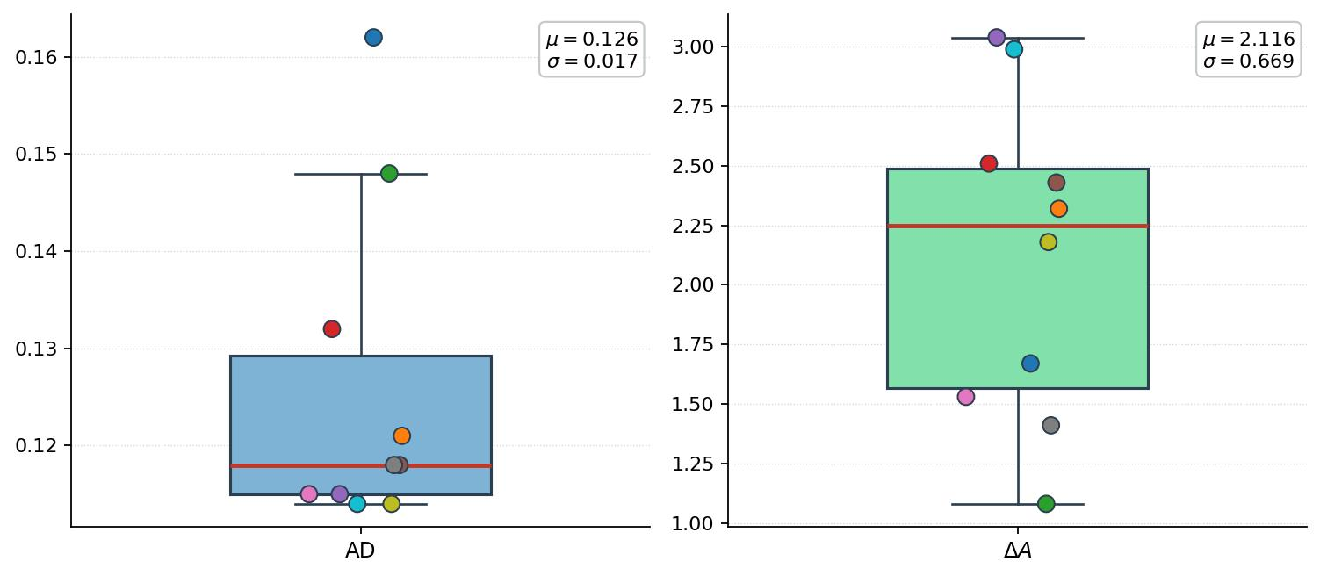
Figure 15. Box plot of the main discrepancy metrics over 10 independent capture sessions. Colored dots are individual runs, numbered as in Table 1; boxes show the interquartile range, whiskers — the min–max.
The systematic (not random) overestimate of the measured area relative to the reference, by $+2.12$% on average, warrants separate analysis. The distribution of the measured area across the sessions is shown in Figure 16. The most likely sources of this bias are (i) a small residual gap at the seam between the main foot model and the lesion insert, arising during FDM printing: this gap can systematically inflate the area of the edge triangles of the 3D mesh within the region; (ii) a “fuller” reconstruction of the region boundary by the real lens compared to the ideally flat CAD projection, because the edge triangles of the 3D mesh partially cover pixels beyond the CAD fragment; (iii) an additional contribution from the 3D-printing error of the phantom, which we do not measure metrologically here. Investigating ways to eliminate this gap and an independent measurement of print accuracy are subjects for future work.
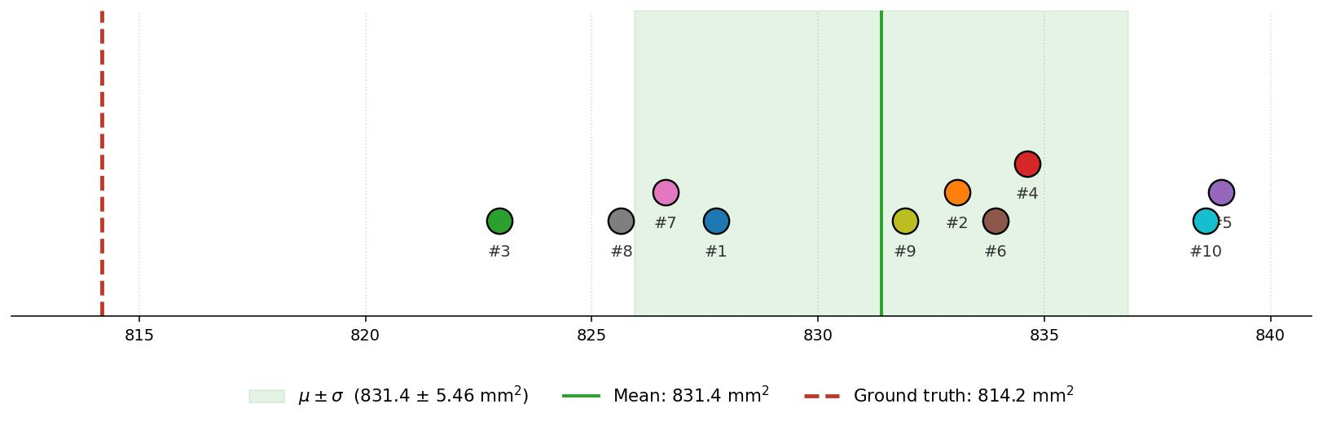
Figure 16. Distribution of the measured lesion-region area over 10 independent capture sessions. The red vertical line is the reference value $A_{\text{ref}}=814.18$ mm$​^{2}$; colored dots are individual runs, numbered as in Table 1.

8.2 Comparison with SALVE
In SALVE [1], Neus-Facto was tested on three TraumaSIM silicone phantoms (PIS3, PIS4, SD) captured with an iPhone 14 Pro Max, with the reference from a Revopoint POP 2 structured-light 3D scanner (declared scanner accuracy ∼0.3 mm). SALVE’s main metrics for Neus-Facto on the iPhone capture (Table 3): AD in the range 0.215–0.355 mm depending on the phantom, HD 1.990–9.956 mm, HD₉₀ 0.499–0.730 mm.
Table 3. Direct comparison of our main metrics with the Neus-Facto results published in SALVE for iPhone capture of the three TraumaSIM phantoms. For our work, the min–max over 10 runs is shown.
Setting | AD (mm) | HD (mm) | HD₉₀ (mm)
This work | 0.114–0.162 | 0.659–0.881 | 0.185–0.258
SALVE / PIS3 (iPhone) | 0.215 | 2.689 | 0.499
SALVE / PIS4 (iPhone) | 0.355 | 9.956 | 0.730
SALVE / SD (iPhone) | 0.216 | 1.990 | 0.499
On all three SALVE-comparable metrics, our setup demonstrates better results than each of the three SALVE phantoms. Our work does not claim to improve Neus-Facto itself: the identical algorithm is used in both setups. Rather, it shows that with a controlled reference (CAD), automatic segmentation, and deliberate attention to the capture considerations described in Section 5 (distance selection with respect to DOF/detail, ensuring angular coverage, exposure and focus control, stable lighting), the achievable accuracy of the method can be substantially better than previously documented. The robustness of Neus-Facto to changing capture conditions claimed in SALVE is now also confirmed for the repeatability of the end-to-end pipeline across separate physical sessions.

8.3 Sensitivity to capture conditions
The capture considerations described in Section 5 — distance selection with respect to the trade-off between depth of field and pixel-level detail, ensuring sufficient angular coverage, stable exposure without extremes, and uniform lighting — have a critical impact on the quality of the final result; this was confirmed empirically in our work. Several of the photo sessions had to be repeated because the initially captured material did not allow a reconstruction of acceptable quality — the meshes exhibited significant surface artifacts that could not be removed either by varying the Neus-Facto hyperparameters or by post-processing. Only the sessions on which these criteria were met entered the final sample of 10 runs.
It is worth emphasizing that the failed sessions were not detectable in advance from the photographs themselves: the individual frames looked sharp and well-exposed, and the problems only became apparent after the full reconstruction cycle. This suggests that simple per-frame quality checks are insufficient as an acceptance criterion for capture material; what matters is the geometric consistency of the whole set — the actual angular coverage, parallax between neighboring frames, and the stability of the photometric conditions across the session. In practical deployment, an automated pre-flight check of the captured set — verifying the frame count, the coverage of the orbit, the parallax between neighboring frames, and the exposure drift before any training is launched — could replace this trial-and-error loop and make the acceptance criterion explicit rather than implicit.

9. Conclusions
The conducted experiments support the following main conclusions.
First, the Neus-Facto method — and, more broadly, the SDF family of neural implicit surface reconstruction methods — is suitable for practical use in the task of measuring skin-lesion area under conditions close to clinical ones. With the proposed capture setup on an ordinary smartphone, the achieved surface-geometry accuracy is sub-millimeter (AD = 0.114–0.162 mm on all 10 independent sessions) and the repeatability of the measured area is at the level of CV = 0.66%, well below the typical clinical significance of lesion-area changes during monitoring.
Second, the quality of the input material has a critical impact on the quality of the final reconstruction. This is evident both from the direct comparison with the SALVE results on the TraumaSIM phantoms and from our own experience: some photo sessions had to be repeated because an acceptable surface quality could not be obtained from them. Adherence to the basic capture principles described in Section 5 is a necessary precondition for obtaining quality results.
Third, although the method itself can produce accurate results, it requires adherence to the aforementioned capture conditions, which in turn demands a certain level of skill and understanding of these principles from the operator. This places certain limitations on applying the approach in broad clinical practice. At the same time it outlines a direction for further research — the development of dedicated capture-assistance tools that would automatically account for the described considerations and the clinical context of use, thereby lowering the skill requirements on the operator without loss of reconstruction quality.
Fourth, the evaluation was conducted on a single phantom with a fixed lesion-region geometry; validating the approach on a broader range of shapes, sizes, and anatomical locations is a natural continuation of this work. The FDM-printing error of the phantom itself was not measured metrologically here and was assumed at the level of the printer specification; its independent assessment will allow the contribution of the method itself to be more precisely separated from the contribution of the reference geometry in the observed deviations.
The described experimental approach — a digital CAD model of the object as the reference instead of a third-party measurement system — is a methodological contribution in its own right and can be applied to evaluating other 3D reconstruction methods in tasks where the reference geometry requires accuracy that is hard to achieve with external measurement instruments.
Author Contributions: Conceptualization, R.B. and S.L.; Methodology, M.M. and R.B.; Software, R.B. and W.Z.; Validation, M.M. and R.B.; Visualization, R.B. and M.M.; Formal analysis, R.B., M.M. and W.Z.; Investigation, W.Z. and M.M.; Data curation, R.B. and M.M.; Writing—original draft, R.B.; Writing–review and editing, M.M.; Supervision, W.Z.; Project administration, M.M. and W.Z.; Resources, M.M.; Funding acquisition, W.Z. All authors have read and agreed to the published version of the manuscript.
Funding: This research received no external funding.
Data Availability Statement: The smartphone photographs of the phantom used as input and the 3D models (meshes) reconstructed in this study are openly available at https://github.com/rburkovsky/neus-facto-article (accessed on 16 September 2026). Additional data are available from the corresponding author upon reasonable request.
Conflicts of Interest: The authors declare no conflict of interest.

References
- Chierchia, R.; Lebrat, L.; Ahmedt-Aristizabal, D.; Salvado, O.; Fookes, C.; Santa Cruz, R. SALVE: A 3D Reconstruction Benchmark of Wounds from Consumer-Grade Videos. In Proceedings of the IEEE/CVF Winter Conference on Applications of Computer Vision (WACV), Tucson, AZ, USA, 28 February – 4 March 2025; pp. 4205–4214. https://doi.org/10.1109/WACV61041.2025.00413.
- Wang, E.; Feng, S.; Zhang, J.; Qiu, H.; Gu, Y.; Chen, D. Deep learning-enhanced COLMAP for 3D reconstruction and segmentation of facial port-wine stains for comprehensive evaluation. Quant. Imaging Med. Surg. 2025, 15, 12303–12319. https://doi.org/10.21037/qims-2025-112.
- Medela, A.; Sabater, A.; Fernández, G.; Mac Carthy, T.; Aguilar, A.; Herrera, D.; Falqués, M.; Martorell, A. Overcoming measurement challenges in clinical practice: a deep learning-based approach to monocular surface area measurement. Skin Health Dis. 2026, 6, 519–527. https://doi.org/10.1093/skinhd/vzag064.
- Kerbl, B.; Kopanas, G.; Leimkuehler, T.; Drettakis, G. 3D Gaussian Splatting for Real-Time Radiance Field Rendering. ACM Trans. Graph. 2023, 42, 139. https://doi.org/10.1145/3592433.
- Wang, P.; Liu, L.; Liu, Y.; Theobalt, C.; Komura, T.; Wang, W. NeuS: Learning Neural Implicit Surfaces by Volume Rendering for Multi-view Reconstruction. In Proceedings of the 35th Conference on Neural Information Processing Systems (NeurIPS 2021), Online, 6–14 December 2021; pp. 27171–27183. https://arxiv.org/abs/2106.10689.
- Li, Z.; Müller, T.; Evans, A.; Taylor, R.H.; Unberath, M.; Liu, M.-Y.; Lin, C.-H. Neuralangelo: High-Fidelity Neural Surface Reconstruction. In Proceedings of the IEEE/CVF Conference on Computer Vision and Pattern Recognition (CVPR), Vancouver, BC, Canada, 17–24 June 2023; pp. 8456–8465. https://doi.org/10.1109/CVPR52729.2023.00817.
- Yu, Z.; Chen, A.; Antic, B.; Peng, S.; Bhattacharyya, A.; Niemeyer, M.; Tang, S.; Sattler, T.; Geiger, A. SDFStudio: A Unified Framework for Surface Reconstruction. 2022. Available online: https://autonomousvision.github.io/sdfstudio/ (accessed on 14 September 2026).
- Lebrat, L.; Santa Cruz, R.; Chierchia, R.; Arzhaeva, Y.; Armin, M.A.; Goldsmith, J.; Oorloff, J.; Reddy, P.; Nguyen, C.; Petersson, L.; et al. Syn3DWound: A Synthetic Dataset for 3D Wound Bed Analysis. In Proceedings of the 2024 IEEE International Symposium on Biomedical Imaging (ISBI), Athens, Greece, 27–30 May 2024; pp. 1–5. https://doi.org/10.1109/ISBI56570.2024.10635420.
- Guédon, A.; Lepetit, V. SuGaR: Surface-Aligned Gaussian Splatting for Efficient 3D Mesh Reconstruction and High-Quality Mesh Rendering. In Proceedings of the IEEE/CVF Conference on Computer Vision and Pattern Recognition (CVPR), Seattle, WA, USA, 16–22 June 2024; pp. 5354–5363. https://doi.org/10.1109/CVPR52733.2024.00512.
- Huang, B.; Yu, Z.; Chen, A.; Geiger, A.; Gao, S. 2D Gaussian Splatting for Geometrically Accurate Radiance Fields. In Proceedings of the ACM SIGGRAPH 2024 Conference Papers (SIGGRAPH ’24), Denver, CO, USA, 27 July – 1 August 2024; Article 32. https://doi.org/10.1145/3641519.3657428.
- Yan, Z.; Mazzacca, G.; Rigon, S.; Farella, E.M.; Trybala, P.; Remondino, F. NeRFBK: A Holistic Dataset for Benchmarking NeRF-Based 3D Reconstruction. Int. Arch. Photogramm. Remote Sens. Spat. Inf. Sci. 2023, XLVIII-1/W3-2023, 219–226. https://doi.org/10.5194/isprs-archives-XLVIII-1-W3-2023-219-2023.
- Ren, X.; Wang, W.; Cai, D.; Tuominen, T.; Kannala, J.; Rahtu, E. MuSHRoom: Multi-Sensor Hybrid Room Dataset for Joint 3D Reconstruction and Novel View Synthesis. In Proceedings of the IEEE/CVF Winter Conference on Applications of Computer Vision (WACV), Waikoloa, HI, USA, 3–8 January 2024; pp. 4496–4505. https://doi.org/10.1109/WACV57701.2024.00445.
- Turkulainen, M.; Ren, X.; Melekhov, I.; Seiskari, O.; Rahtu, E.; Kannala, J. DN-Splatter: Depth and Normal Priors for Gaussian Splatting and Meshing. In Proceedings of the IEEE/CVF Winter Conference on Applications of Computer Vision (WACV), Tucson, AZ, USA, 28 February – 4 March 2025; pp. 2421–2431. https://doi.org/10.1109/WACV61041.2025.00241.
- Chierchia, R.; Santa Cruz, R.; Lebrat, L.; Arzhaeva, Y.; Armin, M.A.; Oorloff, J.; Nguyen, C.; Salvado, O.; Fookes, C.; Ahmedt-Aristizabal, D. Wound3DAssist: A Practical Framework for 3D Wound Assessment. arXiv 2025, arXiv:2508.17635. https://arxiv.org/abs/2508.17635.
- Chierchia, R.; Lebrat, L.; Ahmedt-Aristizabal, D.; Arzhaeva, Y.; Salvado, O.; Fookes, C.; Santa Cruz, R. Multi-view Consistent Wound Segmentation with Neural Fields. arXiv 2026, arXiv:2601.16487. https://arxiv.org/abs/2601.16487.
- Mirzaalian Dastjerdi, H.; Töpfer, D.; Rupitsch, S.J.; Maier, A. Measuring Surface Area of Skin Lesions with 2D and 3D Algorithms. Int. J. Biomed. Imaging 2019, 2019, 4035148. https://doi.org/10.1155/2019/4035148.
- Chang, C.W.; Wang, H.; Lai, F.; Christian, M.; Huang, S.C.; Tsai, H.Y. Comparison of 3D and 2D area measurement of acute burn wounds with LiDAR technique and deep learning model. Front. Artif. Intell. 2025, 8, 1510905. https://doi.org/10.3389/frai.2025.1510905.
- Mildenhall, B.; Srinivasan, P.P.; Tancik, M.; Barron, J.T.; Ramamoorthi, R.; Ng, R. NeRF: Representing Scenes as Neural Radiance Fields for View Synthesis. In Proceedings of the European Conference on Computer Vision (ECCV), Glasgow, UK, 23–28 August 2020; pp. 405–421. https://doi.org/10.1007/978-3-030-58452-8_24.
- Lorensen, W.E.; Cline, H.E. Marching Cubes: A High Resolution 3D Surface Construction Algorithm. In Proceedings of the 14th Annual Conference on Computer Graphics and Interactive Techniques (SIGGRAPH ’87), Anaheim, CA, USA, 27–31 July 1987; pp. 163–169. https://doi.org/10.1145/37401.37422.
- Ray, S.F. Applied Photographic Optics, 3rd ed.; Focal Press: Oxford, UK, 2002.
- Luhmann, T.; Robson, S.; Kyle, S.; Boehm, J. Close-Range Photogrammetry and 3D Imaging, 3rd ed.; De Gruyter: Berlin, Germany, 2019. https://doi.org/10.1515/9783110607253.
- Idiculla, J.; Pakalomattom, S.; Desai, A.; Philip, B.; Shobha, V. Neurofibromatosis type 1 and lymphocytic hypophysitis: Single trigger and double shots? Internet J. Rheumatol. Clin. Immunol. 2015, 3, 104. https://doi.org/10.15305/ijrci/v3i1/104.
- International Skin Imaging Collaboration. ISIC Archive, Image ISIC_0011293 (Lentigo). Available online: https://api.isic-archive.com/images/ISIC_0011293/ (accessed on 14 September 2026).
- International Skin Imaging Collaboration. ISIC Archive, Image ISIC_0000155 (Melanoma). Available online: https://api.isic-archive.com/images/ISIC_0000155/ (accessed on 14 September 2026).
- ASIMOVSTUDIOS. Human foot Free 3D print model. CGTrader. Available online: https://www.cgtrader.com/free-3d-print-models/art/sculpture/human-foot-caf6af24-8c2c-491e-b954-e3618e3b5b57 (accessed on 14 September 2026).
- Schönberger, J.L.; Frahm, J.-M. Structure-from-Motion Revisited. In Proceedings of the IEEE Conference on Computer Vision and Pattern Recognition (CVPR), Las Vegas, NV, USA, 27–30 June 2016; pp. 4104–4113. https://doi.org/10.1109/CVPR.2016.445.
- Garland, M.; Heckbert, P.S. Surface Simplification Using Quadric Error Metrics. In Proceedings of the 24th Annual Conference on Computer Graphics and Interactive Techniques (SIGGRAPH ’97), Los Angeles, CA, USA, 3–8 August 1997; pp. 209–216. https://doi.org/10.1145/258734.258849.
- Zheng, P.; Gao, D.; Fan, D.-P.; Liu, L.; Laaksonen, J.; Ouyang, W.; Sebe, N. Bilateral Reference for High-Resolution Dichotomous Image Segmentation. CAAI Artif. Intell. Res. 2024, 3, 9150038. https://doi.org/10.26599/AIR.2024.9150038.
- Kirillov, A.; Mintun, E.; Ravi, N.; Mao, H.; Rolland, C.; Gustafson, L.; Xiao, T.; Whitehead, S.; Berg, A.C.; Lo, W.-Y.; et al. Segment Anything. In Proceedings of the IEEE/CVF International Conference on Computer Vision (ICCV), Paris, France, 1–6 October 2023; pp. 3992–4003. https://doi.org/10.1109/ICCV51070.2023.00371.
- Loop, C. Smooth Subdivision Surfaces Based on Triangles. M.S. Thesis, University of Utah, Salt Lake City, UT, USA, 1987.
- Ester, M.; Kriegel, H.-P.; Sander, J.; Xu, X. A Density-Based Algorithm for Discovering Clusters in Large Spatial Databases with Noise. In Proceedings of the Second International Conference on Knowledge Discovery and Data Mining (KDD-96), Portland, OR, USA, 2–4 August 1996; pp. 226–231.
- Umeyama, S. Least-Squares Estimation of Transformation Parameters Between Two Point Patterns. IEEE Trans. Pattern Anal. Mach. Intell. 1991, 13, 376–380. https://doi.org/10.1109/34.88573.
- Zhou, Q.-Y.; Park, J.; Koltun, V. Open3D: A Modern Library for 3D Data Processing. arXiv 2018, arXiv:1801.09847. https://arxiv.org/abs/1801.09847.
- Rubner, Y.; Tomasi, C.; Guibas, L.J. The Earth Mover’s Distance as a Metric for Image Retrieval. Int. J. Comput. Vis. 2000, 40, 99–121. https://doi.org/10.1023/A:1026543900054.
- Flamary, R.; Courty, N.; Gramfort, A.; Alaya, M.Z.; Boisbunon, A.; Chambon, S.; Chapel, L.; Corenflos, A.; Fatras, K.; Fournier, N.; et al. POT: Python Optimal Transport. J. Mach. Learn. Res. 2021, 22, 1–8. https://jmlr.org/papers/v22/20-451.html.
- Tatarchenko, M.; Richter, S.R.; Ranftl, R.; Li, Z.; Koltun, V.; Brox, T. What Do Single-View 3D Reconstruction Networks Learn? In Proceedings of the IEEE/CVF Conference on Computer Vision and Pattern Recognition (CVPR), Long Beach, CA, USA, 15–20 June 2019; pp. 3400–3409. https://doi.org/10.1109/CVPR.2019.00352.
Disclaimer/Publisher’s Note: The statements, opinions and data contained in all publications are solely those of the individual author(s) and contributor(s) and not of MDPI and/or the editor(s). MDPI and/or the editor(s) disclaim responsibility for any injury to people or property resulting from any ideas, methods, instructions or products referred to in the content.

